|  |  |  |
| --- | --- | --- |
| What | Type | Definition |
| Page templates | Presentation | Fully-formed HTML files that define the layout and high-level look-and-feel of web pages, including the placement of contribution regions (that is, editable areas on the page), navigation aids (in the form of fragments) and site-wide images (banners and the like). Page templates are the highest-level site design object.  Page Templates are at the top of the hierarchy. They provide the framework for the pages in a Web site within which the site content is displayed. In addition to standard HTML layout and formatting code, they contain site-wide images and other assets, and tags for fragments and/or placeholders. Page templates are stored and managed on the content server. |
| Subtemplates | Presentation | Subtemplates are the same as page templates, but with one important difference: subtemplates do not have <HTML>, <HEAD>, and <BODY> tags. As such, they are essentially chunks of HTML code that can be inserted in page templates.  Partial HTML files (that is, without head and body sections) that can be inserted into placeholders on page templates to divide them into further smaller, reusable areas with their own placeholders and contribution regions.  A subtemplate is a partial HTML file (that is, without a head and body section) that provides a mechanism to divide a placeholder on a page template into further smaller, reusable areas with their own placeholder(s). There is a circular relationship between placeholders and subtemplate; that is, a placeholder may contain a subtemplate, which, in turn, may include one or more placeholders. Subtemplates are stored and managed on the content server. |

|  |  |  |
| --- | --- | --- |
| What | Type | Definition |
| Element definitions | Control and Configuration | Files that define the editing experience for element types. Specifically, they specify what a contributor can do when editing an element.  Elements are the smallest chunks of reusable information in a Site Studio Web site. They are referenced in region templates, which causes their data to be pulled into the region template using the layout and presentation defined in the template. A region template may contain multiple element references. There are no files associated with elements as such; that is, there are no "element files" on the content server. Groups of elements are arranged in region definitions, which specify site content types. Elements are controlled by element definitions, which specify the editing experience available to contributors for an element type. Specifically, they set the available editing features in the Contributor editor when a contributor is editing elements in a contributor data file. |
| Region definitions | Control and Configuration | Think of it as a Type of Content for example a Press Release. A press release may consist of a title, an image, and a body. So a region definition will specify three elements that are of types: ‘text-only’ = title, ‘image’, and ‘wysiwig’=body.  Files that define the type of content that elements of a particular type consists of. They also specify the content creation and switching options available to contributors for contribution regions, and set default metadata for content files associated with these regions. |

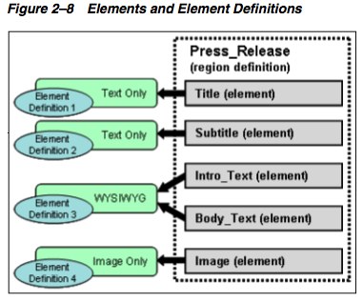

|  |  |  |
| --- | --- | --- |
| What | Type | Definition |
| Region templates | Presentation | Region Templates are associated with Region Definitions. They don’t need to use all the elements specified in a Region Definition. For example you could have a teaser page and then a link to the full page. 2 Region Templates, 1 Region Definition and 1Data File.  Partial HTML files (that is, without head and body sections) that define the layout and look-and-feel of the data in contribution regions within web pages.  A region template is a partial HTML file (that is, without a head and body section) that defines the layout and look-and-feel of the data in a contribution region (marked on a page template using a placeholder tag). Region templates are controlled by region definitions, which define what kind of content can go in the region template. They also specify the content creation and switching options available to contributors for the contribution region, and set default metadata for content files associated with the region. Both region templates and region definitions are stored and managed as separate assets on the content server. A region template may have one or more references to elements. |

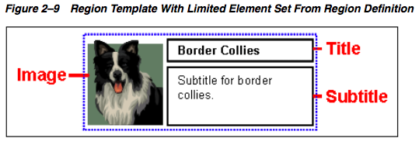

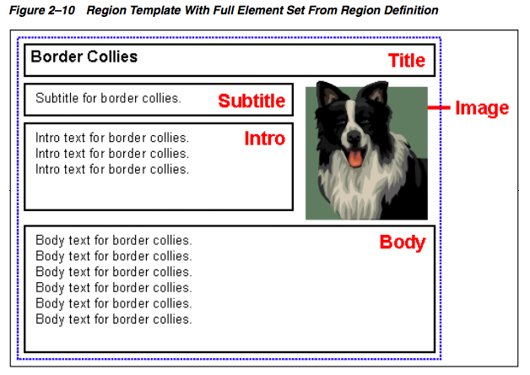

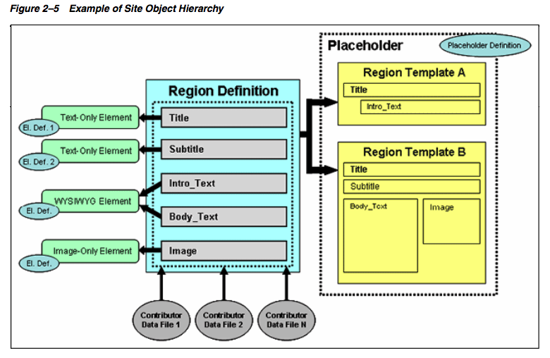

|  |  |  |
| --- | --- | --- |
| What | Type | Definition |
| Contributor data files | Content | Content files in XML format that are generated by Site Studio. Contributor data files are edited using the Site Studio Contributor application. |
| Native documents | Content | Content files created using familiar third-party applications such as Microsoft Word. Native documents are converted to HTML format using Dynamic Converter, and they are edited using their associated application. |
| Placeholder definitions | Control and Configuration | Files that define what region definitions, region templates, and subtemplates are allowed for the associated placeholders. They also specify what contributor actions are allowed for the placeholders.  A placeholder is no more than an insertion point (a tag) on a page template to identify where there is a contribution region (that is, editable area) on the web page. What that contribution region contains and what it looks like is defined using region templates and region definitions. A page template may contain multiple placeholders. There are no files associated with placeholders; that is, there are no "placeholder files" on the content server. Placeholders are controlled by placeholder definitions, which specify what content can go in the contribution region and how it is displayed, as well the actions available to contributors (for example, switching content or modifying metadata). A placeholder contains either one subtemplate or one region template. |
| Fragment libraries | Control and Configuration | Collections of chunks of code (fragments) that enhance the functionality of a Site Studio Web site (for example, by providing dynamic navigation aids or a standard page footer).  are chunks of code that can be added to a page template to enhance its functionality. Site Studio comes with several predefined fragments (for example, for dynamic navigation aids), but you can also create your own fragments. A page template may contain multiple fragments. Fragments are stored in fragment libraries. |
| Manager configuration settings | Control and Configuration | Files that define the functionality that is available in Site Studio Manager. Manager is a web-based tool that allows designated users (site managers) to modify the structure of a Web site. |
| Conversion definitions | Control and Configuration | Files that specify the conversion rules for native documents on a Web site. |